Case 10-AM,S-Bolivia-Tiwanaku-Bone Carving-600-1200 CE

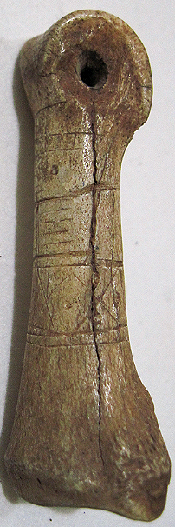 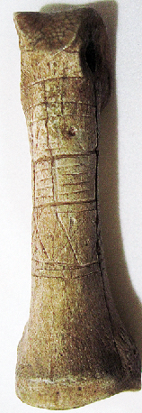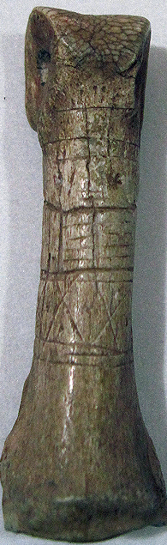 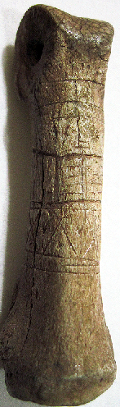 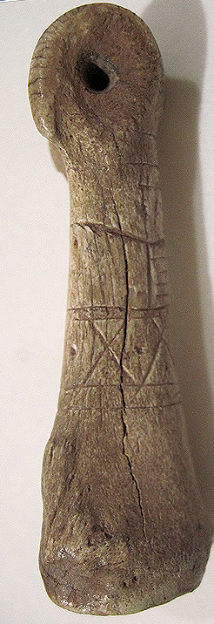 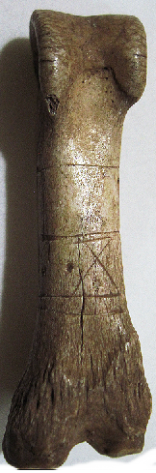

**Case no.:**

**Accession Number:**

**Formal Label:** Bolivia-Tiwanaku-Bone Carving-600-1200 CE

**Display Description:**

This llama bone talisman is of an abstract mask design and is reminiscent of the face of *Wiracocha Apu Qun Tiqsi* (*Viracocha Apu Kon-Tiki)* on the Gate of the Sun (Puerta del Sol) at Tiwanaku, western Bolivia. *Wiracocha* is the paramount Inka creator deity who commands the forces of the sea, rain, and Sun to act with his wishes. An alignment of pre-Columbian Wiracocha temples from the ancient city of Tiwanaku (Tiahuanaco) in Bolivia to Cajamarca in northern Peru (ca 1,000 mi, 1,600 km) is documented in Scholten de D'Ebneth, 1985.

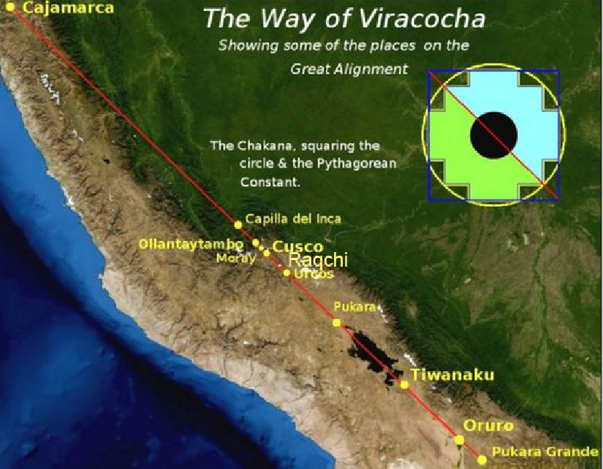Alignment of pre-Columbian Wiracocha temples from Pukara Grande to Tiwanaku (Tiahuanaco) in Bolivia to Pukara to Raqch'i, an Inka town 110 km from Cuzco, to Cajamarca in northern Peru covering a distance of ca 1,000 mi (1,600 km) is documented as the location of temples to Wiracocha in Scholten de D'Ebneth, 1985. Map after https://i.pinimg.com/564x/f0/e3/ab/f0e3ab997b7fbca0f5aca61659a60598.jpg.

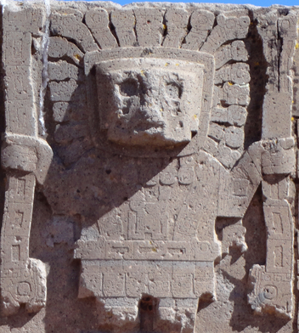 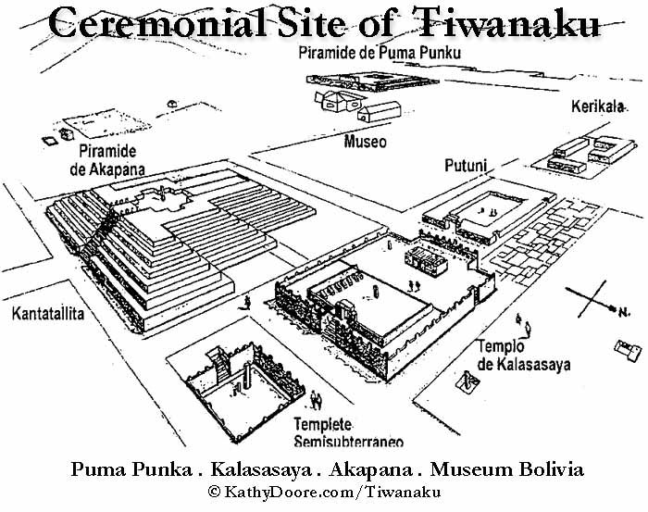

Wiracocha appeared to the people of Raqch'i, an Inka town 110 km from Cuzco on the Vilcanota River (*Willkanuta*, Aymara for "house of the sun," Ministerio del Ambiente. 2010). (The river’s name changes to Urubamba within La Convención Province) The local people did not recognize Wiracocha and attacked him. Then Wiracocha made fire fall from the sky and burned the hills around Raqch'i. Then the Raqch'i people realiized who he was and pleaded forgiveness. Then Wiracocha acknowledged their mistake, and he extinguished the fires with rain. Then the people built a *wak'a* or shrine where he had appeared to them and presented his image with many sacrifices of llamas. The llama bones were then made into talismans like the one presented here.

When Huayna Capac entered Kacha around 1505 (less than 30 years before the Spanish conquest) on his routine inspection of the province and he saw the newly erected wak'a to Wiracocha, so he asked why it was there. The people told him of the miracle that Wiracocha had performed, so Huayna Capac decided that, in the remembrance of this event, there should be an even greater temple erected in Wiracocha’s honor. Garcilaso de la Vega, who was born in Cuzco in 1539, the son of a Spanish Conquistador and an Inca princess. He was educated as a Spanish gentleman and therefore provides an eye-witness description of how people proceeded inside the Wiracocha temple:

Figure 8.   View through a partially restored doorway of the temple showing an original surviving pillar blocking direct access. © Photograph: Bill Sillar. 
                

View through a partially restored doorway of the temple showing an original surviving pillar blocking direct access. © Photograph: Bill Sillar.

“On entering the temple by the main gate, they turned right down the first passage until they came to the wall at the right-hand side of the temple; they then turned left down the second passage and went on till they came to the opposite wall. There they turned right again down the third passage, and by following the series of passages in the plan, ... they came to the twelfth and last, where there was a staircase up to the upper floor (Vega, 1989: 290).

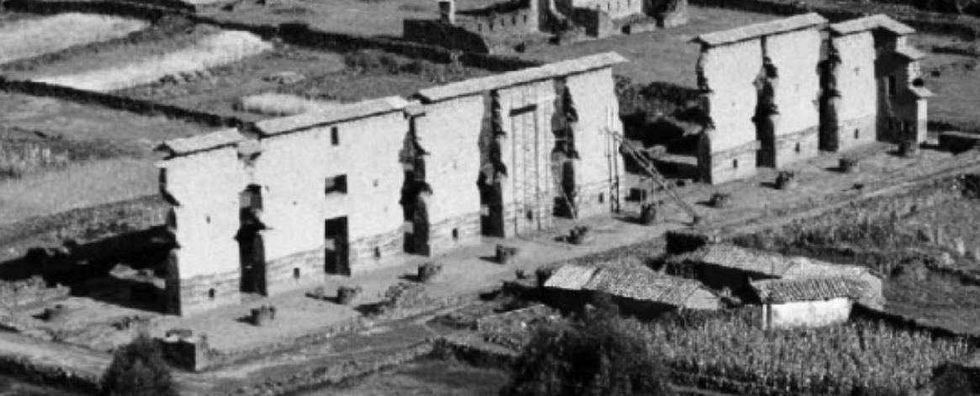

 View of the Inka temple at Raqchi, surviving central wall and pillar bases, with house immediately to the side of the temple wall (1997). © Photograph: Bill Sillar. From https://www.researchgate.net/profile/Bill_Sillar/publication/275485166/figure/fig1/AS:294619909771265@1447254269049/Figure-1-View-of-the-Inka-temple-at-Raqchi-surviving-central-wall-and-pillar-bases.png

Figure 7.   Hypothetical reconstruction of the temple at Raqchi. Drawing by Bethan Davies based on observations in Raqchi,  Gasparini and Margolies’ (1980: 248, Fig. 234) reconstruction drawing,  Betanzos’s (1996[1557], ch. XLV: 175) description of the roof, and  Garcilaso de la Vega’s (1989[1612], Bk 5, ch. XXII: 290) description of how people moved through the building. 
                

Reconstruction of the Raqchi shrine to Wiracocha. Drawing by Bethan Davies based on Gasparini and Margolies reconstruction drawing (1980: 248, Fig. 234), Betanzos’ description of the roof (1996 [1557], ch. XLV: 175), and Garcilaso de la Vega’s (1989 1612], Bk 5, ch. XXII: 290) description.  From https://www.researchgate.net/profile/Bill_Sillar/publication/275485166/figure/fig7/AS:294619918159875@1447254270316/Figure-7-Hypothetical-reconstruction-of-the-temple-at-Raqchi-Drawing-by-Bethan-Davies.png

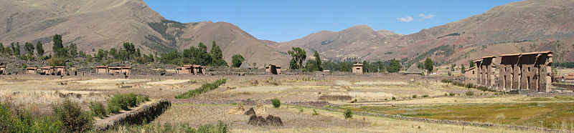

**LC Classification: F3429.3 A65**

**Date or Time Horizon:**

**Geographical Area:**

**Map, GPS coordinates:**

**Cultural Affiliation:**

**Media:**

**Dimensions:** L 65.87 mm, 2.59 in

**Weight: 8 gm, 1/8 oz**

**Condition: original**

**Provenance:** Ex-Geo Fowler, United Kingdom, acquired in Peru between 1933-1935

**Discussion:**

**References:**

Academía Mayor de la Lengua Quechua*, Diccionario Quechua - Español - Quechua*, Cusco: Gobierno Regional.

Ajacopa, Teofilo Laime. 2007. Diccionario Bilingüe Iskay simipi yuyayk'ancha, La Paz.

[Estadísticas de Visitantes de los Museos y Sitios Arqueológicos del Perú (1992-2008)](http://www.congreso.gob.pe/museo/estadisticas.pdf)

Gasparini, G. and L. Margolies. 1980. *Inca architecture.* Tr. P. J. Lyon, Bloomington: Indiana University Press.

Ministerio del Ambiente. 2010. *Estudio linea base ambiental de la cuenca del río Vilcanota*, Lima-Peru.

Niles, Susan. 1999. *The shape of Inca history: narrative and architecture in an Andean Empire*. Iowa City: University of Iowa Press.

Scholten de D'Ebneth, María. 1985. *Tupu: símbolo de integración*. Lima: Editorial J. Mejía Baca,

Sillar, Bill. 2013. The building and rebuilding of walls: Aspirations, commitments and tensions within an Andean community and the archeological monument they inhabit. Journal of Material Culture 18(1), 27-51.

Sillar, Bill. 1999. “[Pilgrims past and present: the ritual landscape of Raqchi, southern Peru](http://www.worldcat.org/title/pilgrims-past-and-present-the-ritual-landscape-of-raqchi-southern-peru/oclc/860049621&referer=brief_results),” *Archaeology International*, 3: 49-52

Sillar, Bill; Emily Dean; Amelia Perez Trujillo. 2013. "My State or Yours? Wari labor camps and the Inka Cult of Viracocha at Raqchi, Cuzco, Peru," *Latin American antiquity*. 24(1): 21-46.

Vega, Garcilaso de la. 1989 [1612] *Royal commentaries of the Incas and general history of Peru.* Tr. H. V. Livermore. Austin: University of Texas Press, 1989 [1612]).

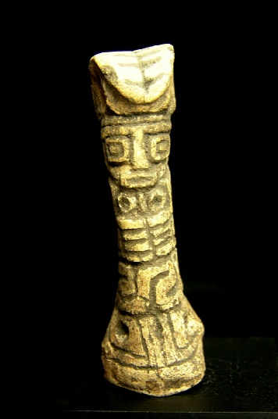

Estimate: $1,200 - $1,800